Dilay Selim
MULTIMEDIA WEB AND DESIGN HOMEWORK WITH JAVASCRIPT
Introduction to JavaScript

Block 1 The Browser Console
Exercise 1.1 — Your first line of code
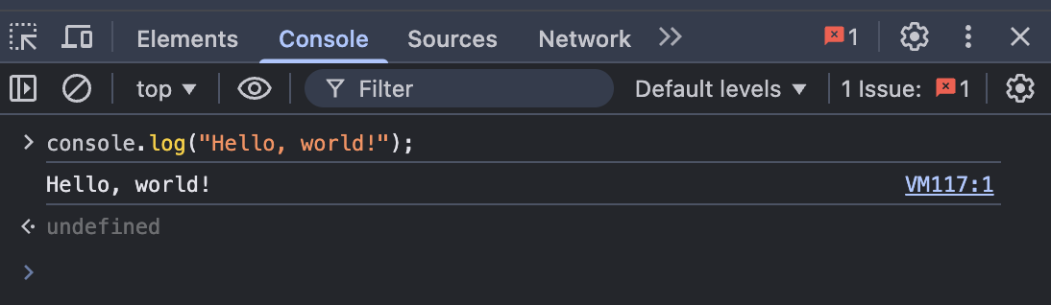

Exercise 1.2 — Basic arithmetic

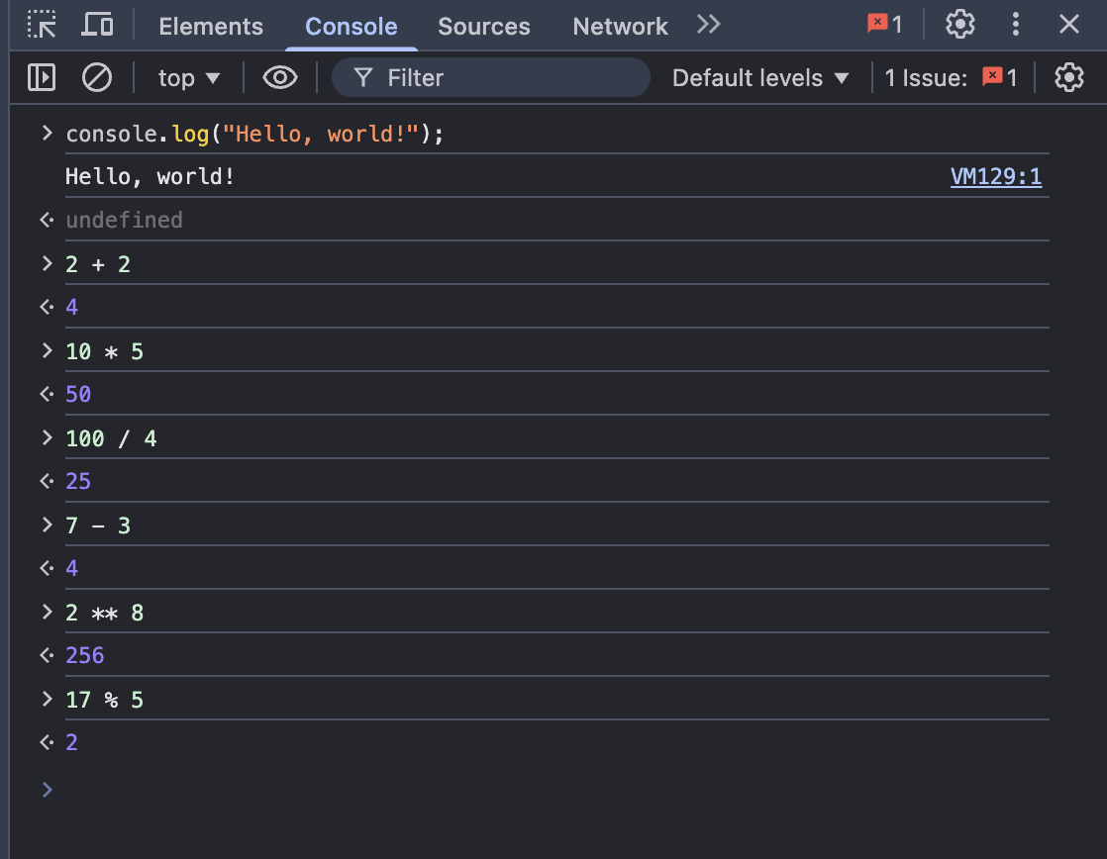

Block 2 Variables and Data Types
Exercise 2.1 — Declaring variables

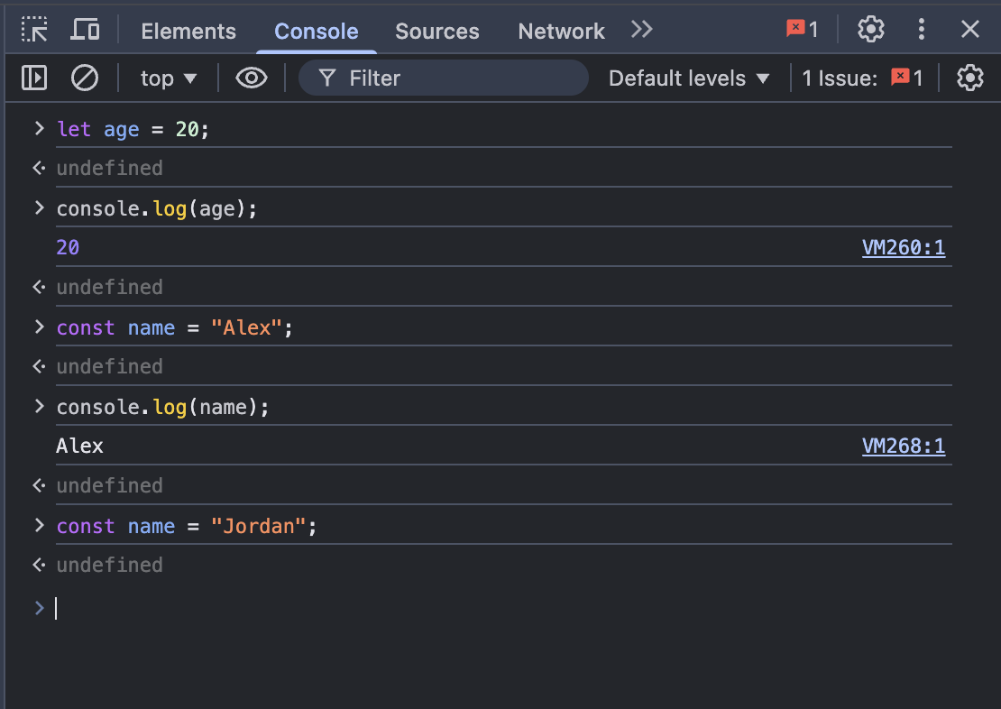

Exercise 2.2 — Data types

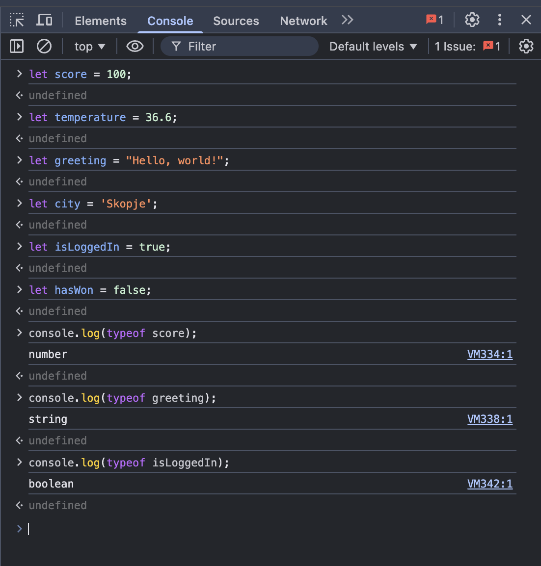

Exercise 2.3 — String operations

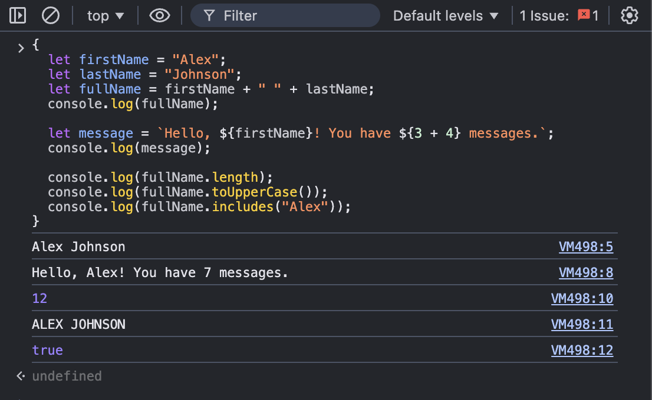

Block 3 Functions
Exercise 3.1 — Your first function
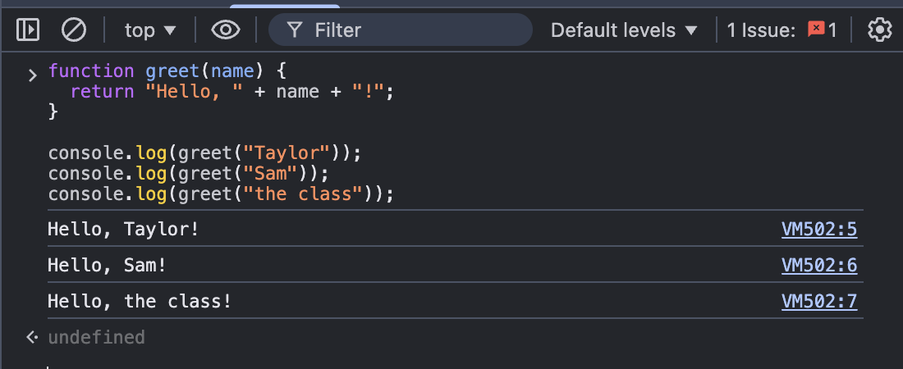

Exercise 3.2 — Arrow functions
Arrow functions are a shorter way to write functions.

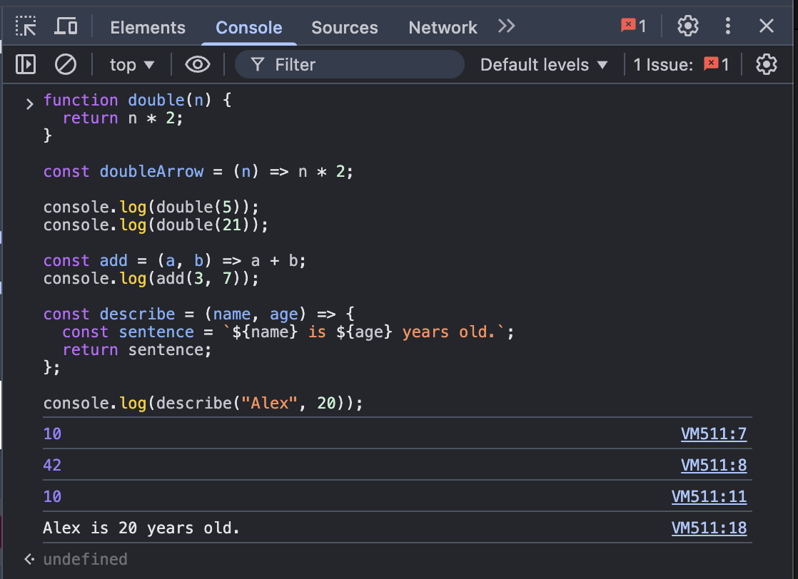

Exercise 3.3 — Challenge: isEven
Write a function that returns true if a number is even, and false if it is odd.

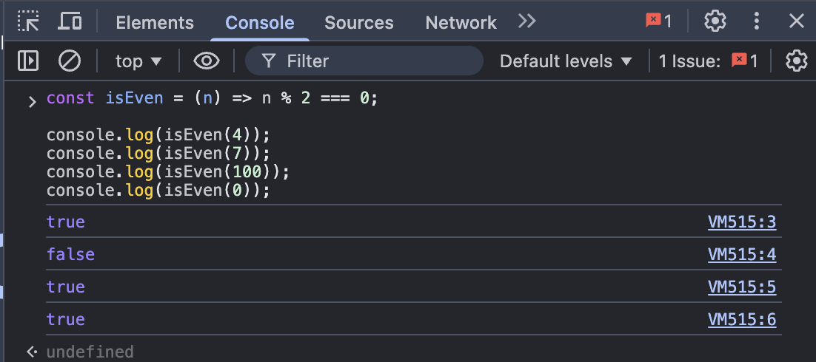

Block 4 Conditionals and Loops
Exercise 4.1 — if / else
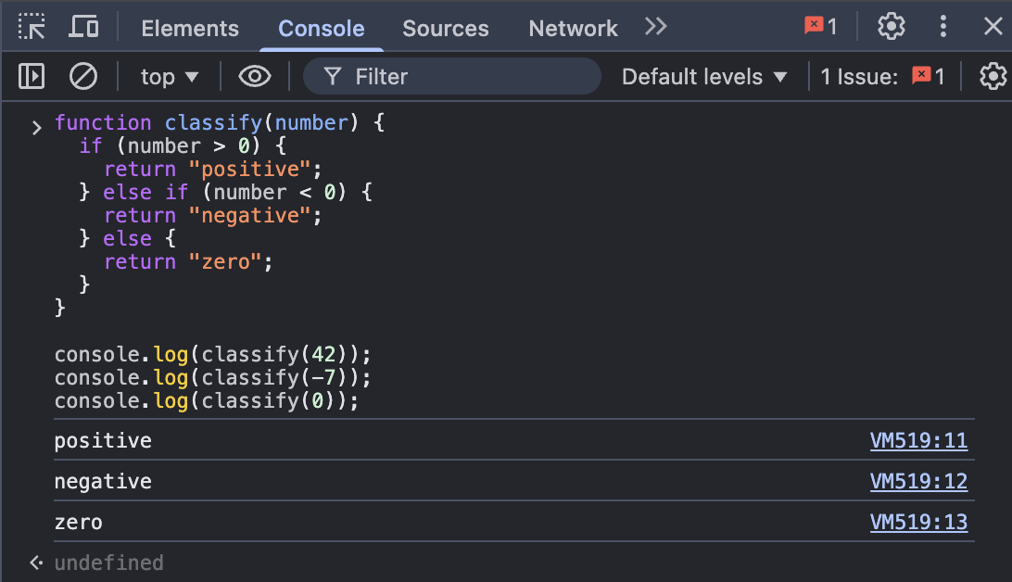

Exercise 4.2 — for loop
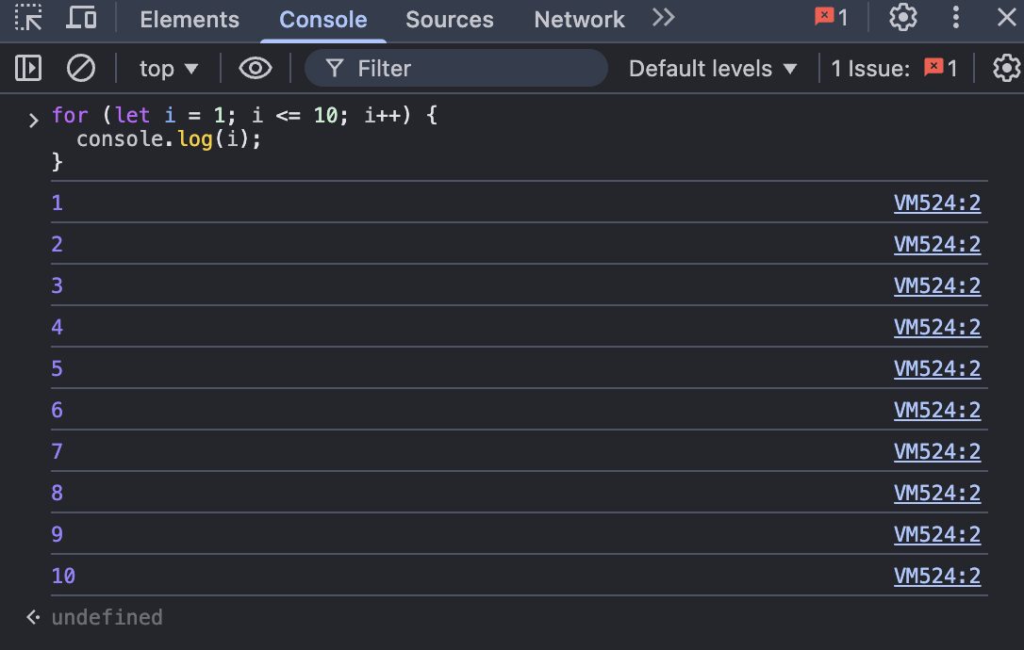

Exercise 4.3 — Combining conditionals and loops

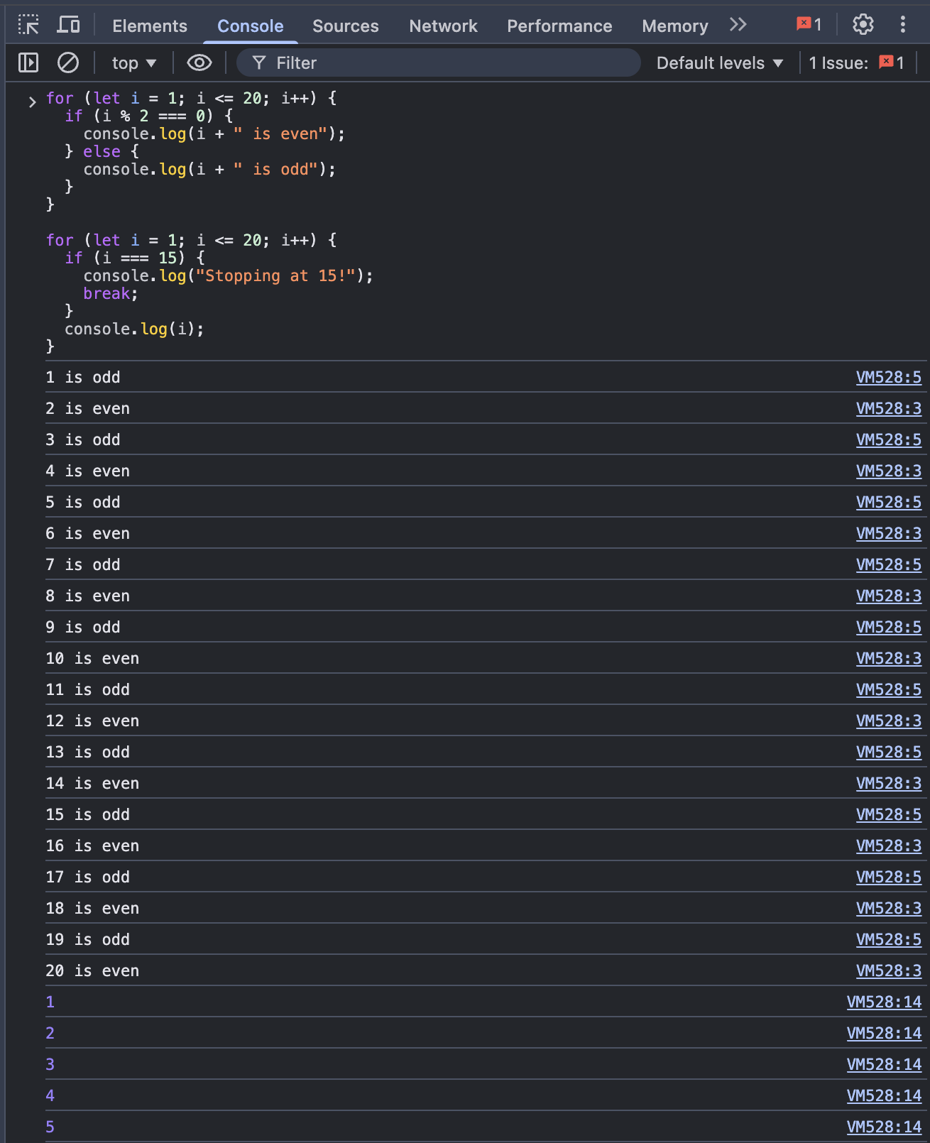
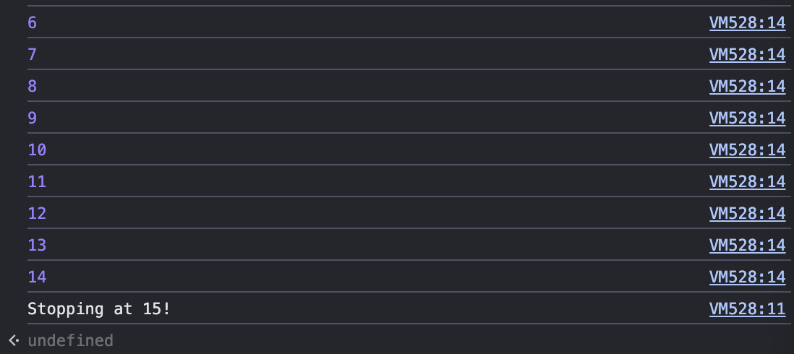

Block 5 Mini Challenge: FizzBuzz
Step-by-step solution
Try writing the solution yourself first.
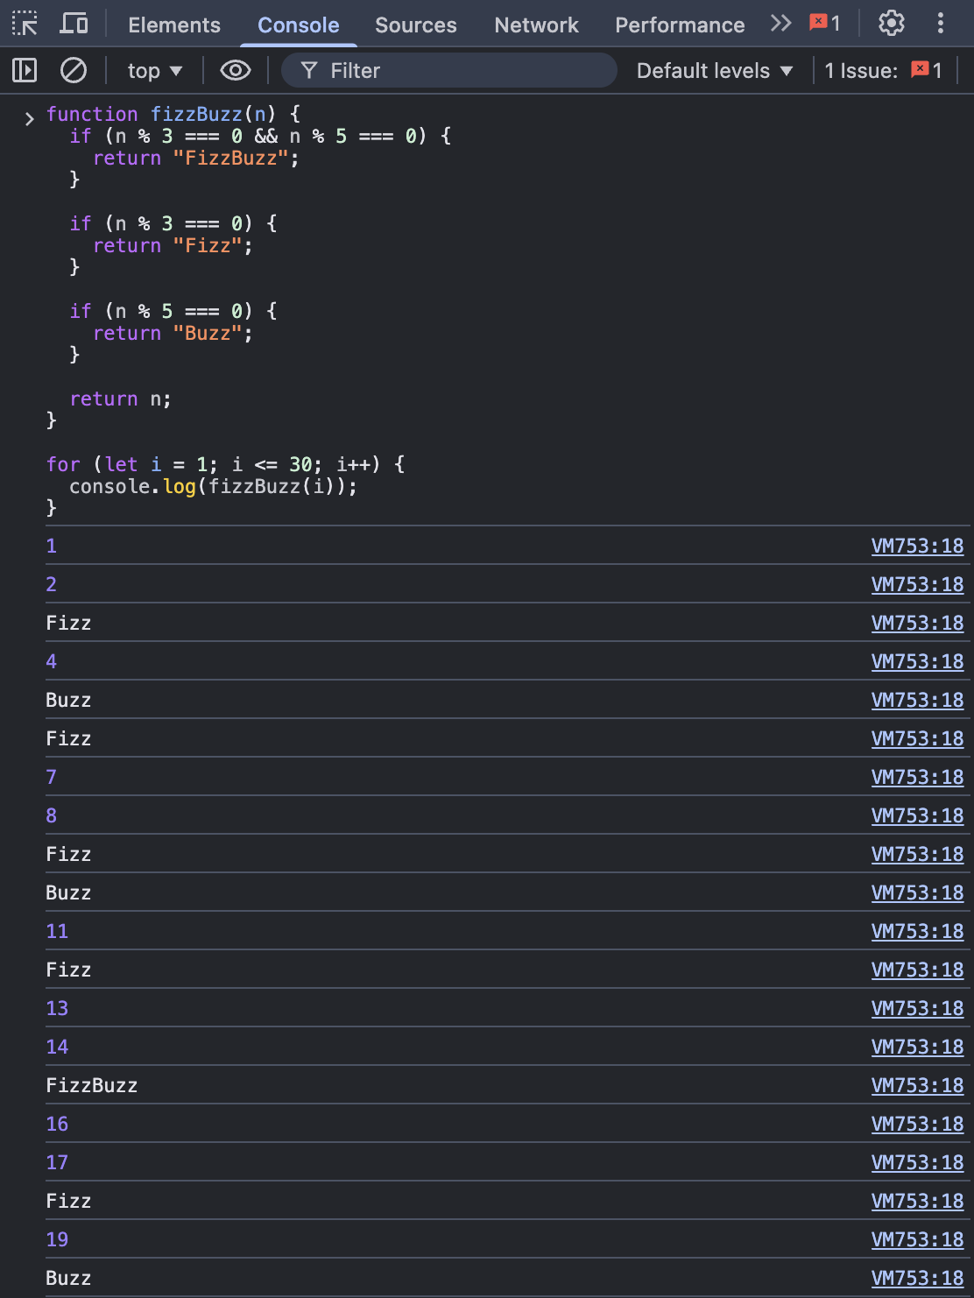

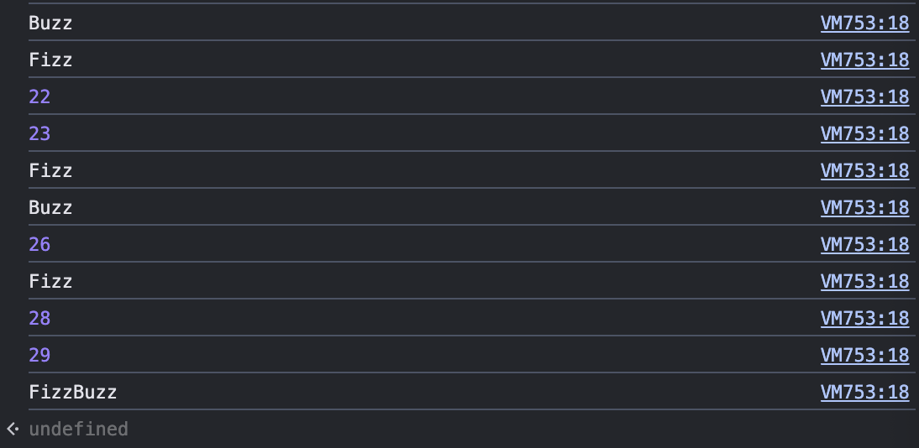

Bonus challenge — add 'Whizz'
